Department of Computer Science and Engineering (Data Science)

S.Y.B.Tech. Sem: IV
Subject: Computational Methods and Pricing Models Laboratory
Experiment 9
Name: SAP ID: Roll No:
Date: | Experiment Title: Implement to demonstrate Value at Risk (VaR) Calculation for a sample Portfolio using Historical data.
Aim | To calculate the Value at Risk (VaR) of a sample investment portfolio using historical simulation and analyze the risk level of the portfolio at different confidence levels.
Software | Python on Google Colab
Theory | Value at Risk (VaR) is a widely used risk measure that quantifies the potential loss in value of a portfolio over a defined period for a given confidence interval.  There are several methods to calculate VaR. In this experiment, we focus on Historical Simulation:  - Historical simulation uses historical returns to simulate the potential changes in portfolio value.  - It does not assume a normal distribution of returns.  Formula:  - Collect historical daily returns.  - Sort the returns in ascending order.  - VaR at α% confidence level = −percentile of sorted returns at (1−α)×100.  For example, a 95% confidence VaR of ₹10,000 means there is a 5% chance that the portfolio will lose more than ₹10,000 on a given day.  Types of Historical VaR Calculation  1. Simplified Historical VaR (Single Observation Method)  - Uses only ONE past observation (one historical return)  - VaR is estimated by scaling a single observed loss to the current portfolio value  This is a basic/manual approach used for concept understanding.  Formula:  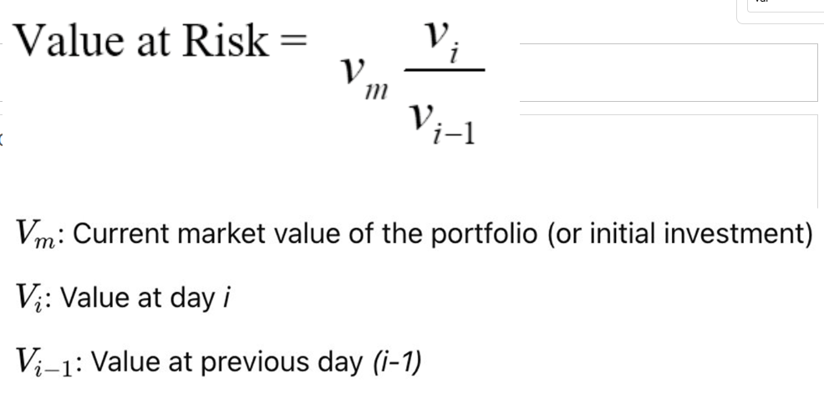  This is:  - Simplified Historical VaR (manual calculation)  2. Historical Simulation VaR (Full Dataset Method)  - Uses many historical returns (e.g., 1 year data)  - Returns are sorted in ascending order  - VaR is calculated using percentile method (e.g., 5%, 1%)  This is:  - A statistical and real-world approach  Represents:  - Proper Historical Simulation VaR  Key Difference  - Simplified method → one past return scaled to current value  - Full method → percentile of full return distribution
Implementation | Step 1: Create a Sample Portfolio  - Choose a set of assets (e.g., 10 stocks).  - Assign weights to each stock.  - Fetch the last 1 year of historical price data.  Step 2: Calculate Daily Returns  - Compute the percentage change in daily prices.  - Calculate the weighted return of the portfolio.  Step 3: Historical VaR Calculation  - Sort the portfolio daily returns.  - Calculate the VaR at 90%, 95%, and 99% confidence levels.  Step 4: Visualize the Risk  - Plot histogram of returns.  - Indicate VaR thresholds on the histogram.  Step 5: Backtesting VaR  - Check how often actual losses exceed VaR estimates.
Extra Task | Variance-Covariance Method (Parametric VaR)  - This method assumes that portfolio returns are normally distributed.  - VaR is calculated using the mean (μ) and standard deviation (σ) of returns.  - It is a formula-based approach, unlike simulation methods.  Formula:  VaR=Zα​⋅σ⋅V  Where:  - Zα​ = Z-score for confidence level (e.g., 1.65 for 95%)  - σ = standard deviation of portfolio returns  V = portfolio value  Variance-Covariance VaR Calculation  - Calculate mean (μ) and standard deviation (σ) of portfolio returns.  - Select confidence levels: 90%, 95%, 99%.  - Find corresponding Z-scores:  - 90% → 1.28  - 95% → 1.65  - 99% → 2.33  - Compute VaR
Final Expected Output | - VaR using Historical Simulation  - VaR using Variance-Covariance method  - Comparison between both methods
Conclusion | (Write your conclusions for all the tasks)

